One of the most important aspects of a successful XML integration with another company is the data mapping. Some decisions on this have to be made very early on during the development process in order to achieve the best results. It is therefore important that the IT, sales and marketing teams of both companies work closely together to understand the challenges and find the most suitable solution. As a start on this we have listed here a few areas that require particular attention. The technical specifications for all of these issues can be found on our XML Support site at http://xml-support.gta-travel.com; this document is intended to provide a summary and to highlight areas that need to be given consideration to BEFORE the development process can be started.

IATA City Codes
GTA uses IATA and non-IATA city codes. The reason for this lies in the fact that we provide many properties, tours and transfers in destinations far away from any airport for which no IATA code exists.

In the past many of our clients have asked us whether we could provide a facility like a mapping table that would map all non-IATA GTA city codes to the existing IATA airport and/or city codes. Unfortunately we have as yet not been able to come up with the right logic for that without the risk that a customer ends up in a completely different city when booking a hotel than he thought he would stay in.

To give an example, there are 15 IATA codes and 61 GTA city codes for places in Austria and only 8 of them are matching. If we take the city of St. Wolfgang the closest airport to this town is Salzburg, about 50km away, so we could map the GTA city code 'STWO' to the IATA code 'SZG'. However, we are worried that if you then perform a price and availability search for the IATA code 'SZG' and we return also properties in St. Wolfgang additionally to all the properties in Salzburg itself, that your customer might choose to book a property in St. Wolfgang without realising that it is 50km away from Salzburg.

Please be aware that not all IATA city codes are directly recognised in GTA; i.e.: Kaunas (IATA: KUN), in this case the GTA city code would be KAUS and no results would be returned at all if you were to use KUN.

You will therefore need to import all GTA city codes and map them to the destinations you are selling or create them as new destinations on your systems. While the import can be done by your IT team there are commercial considerations to be made for which your sales and marketing teams need to be involved.

GTA Item Codes
GTA uses item codes that are only unique in conjunction with our city codes and it is therefore important you map them accordingly to your own internal codes on your systems. For example, the item code for the ROYAL NATIONAL HOTEL in London is ‘ROY2’; this needs to be used in conjunction with our city code for London, which is ‘LON’. Failure to do so might result in the wrong hotel being booked for your customers as we also have a hotel in Edinburgh with the code ‘ROY2’ which is for the ROYAL BRITISH HOTEL’ which in turn needs to be used in conjunction with our city code for Edinburgh which is ‘EDI’. These two hotels have just been used to demonstrate the issue, the principle applies to all our destinations and modules; i.e.: hotels, apartments, sightseeing tours and transfers.

In many cases GTA uses more than one item code for each property to differentiate between different room categories in the same hotel or apartment. Our XML API provides a static data request called <SearchHotelGroupRequest> which allows you to identify the different item codes used for the same property. This in turn will then allow you to enhance the display of your own website and show the room categories under the same property name in a similar way we doing on our own websites. For example, for the Crown Plaza Hotel in Dubai we have five individual item codes under the city code ‘DXB’:
CRO1 - CROWNE PLAZA (Deluxe rooms)
CRO3 - CROWNE PLAZA (Club rooms)
CRO4 - CROWNE PLAZA (1 Bedroom suites)
CROH - CROWNE PLAZA (Superior rooms)
CROJ - CROWNE PLAZA (Studio rooms)

Area Codes – City Codes – Location Codes
In order to give you the greatest flexibility when performing your price and availability searches we offer the facility to enlarge your search from a city-search to an area-search and to narrow it down by specifying a location code as part of a city search. Below we have demonstrated this principle using the city of Nice.
- If you perform a search for the city code of ‘NCE’ we return approximately 80 properties.
- If the same search is narrowed down by adding ‘Beach’ as a search criteria within Nice the same search will only return about 10 properties.
- If you, however, widen your search and use the area code for ‘French Riviera’ which contains Nice and 19 other cities nearby (without specifying the beach as a location) we return about 160 properties.
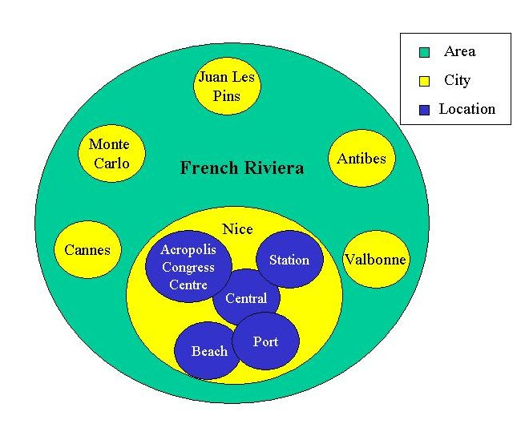
There are four main destination types for which to use our area codes instead of our city codes:

Well known regions
We have created area codes for regions that are better known by their regional destination name then the actual cities within this region.
Example: The Black Forest Region, Germany
GTA city code: no city code with the name ‘Black Forest’ exists on our systems
GTA area code: BFOR
Containing the following GTA city codes:
BAD3 = Bad Peterstal
DONA = Donaueschingen
FREU = Freudenstadt
HCHE = Hochenschwand
QFB = Freiburg
TITI = Titisee
VILI = Villingen-Schwenning
While it is possible to perform a search for the individual city codes a customer who does not know which cities are located in the Black Forest region may just leave your web site in search of another one where this is offered as selection criteria.

Islands
We have created area codes for islands like Malta or Bali where GTA uses different city codes for the different beach locations and the passenger might not know the exact location to visit.
Example: Bali, Indonesia
GTA city code: We have no city code with the name ‘Bali’ but commonly our clients map this destination to the IATA airport code DPS (Denpasar), for which GTA uses the city code DENR.
GTA area code: BALI
Containing the following GTA city codes:
AMAN = Bali-Manggis
BNEG = Bali-Negara
BTUB = Bali-Batubelig Beach
DCAN = Bali-Canggu
DENR = Bali-Denpasar
ECAN = Bali-Candi Dasa
GIAY = Bali-Gianyar
JIMB = Bali-Jimbaran Bay
KROB = Bali-Kerobokan
KUTB = Bali-Kuta Beach
LEGI = Bali-Legian Beach
LMBO = Lembongan Island
MNDU = Bali-Munduk Village
NUSA = Bali-Nusa Dua
SANH = Bali-Sanur Beach
SIGJ = Bali-Singaraja
SMIN = Bali-Seminyak
TABN = Bali-Tabanan
TUBA = Bali-Tuban Beach
UBUD = Bali-Ubud
ULUW = Bali-Uluwatu
- Performing a search just for the city code DENR will return no properties at all as Denpasar city is not a resort location and does not hold any interest for tourists visiting the island.
- Performing a search for the area code BALI will return about 400 properties.
This is an example which demonstrates clearly how important it is to map the destinations you offer to your customers with the right GTA code. Making a mistake here might mean that GTA will never return any results at all while in reality we have plenty of hotels on offer.

Cities with outlying airports
We have created area codes for cities with one or more airports which are too far away to consider part of the city itself.
Example: London, United Kingdom
GTA city code: LON
GTA area code: LONA
Containing the following GTA city codes:
LGW = London Gatwick
LHR = London Heathrow
LON = London
LTN = London Luton
STN = London Stansted
- Performing a search just for the city code LON will return about 400 properties.
- Performing a search for the area code LONA will return about 450 properties.
While the increase is not as significant as in one of our other examples it is important that you give those customers who would like to stay at the airport the opportunity to book these properties as well and do not just offer properties located in the center of the city.

Cities with two or more distinct and separate areas
We have created area codes in cases where we have more than one city code for a destination.
Example: Dubai, United Arab Emirates
GTA city code: DXB
GTA area code: DXB
Containing the following GTA city codes:
DESR = Dubai-Desert
DXB = Dubai City
JUME = Dubai-Jumeirah
- Performing a search just for the city code DXB will return about 340 properties.
- Performing a search for the area code DXB will return about 390 properties.
While the increase is not as significant as in one of our other examples it is important that you give those customers who would like to stay at Jumeira beach or one of the resort hotels in the desert the opportunity to book these properties as well and do not just offer properties located in the old town of Dubai city.

Please note, that the majorities of cities are not included in any area, while some cities are included in more than one area. It is therefore not possible to only use area codes and no city codes at all.

The creation of areas will hopefully make it easier for your sales team and your customers to find the property or service they are looking for without being fully familiar with the destination they are travelling to. Using the area codes rather than the city codes will mean that your search results will display more items and thereby give you a wider choice for your customers to choose from and a greater chance to secure a sale.

